**Importance of Motorcyclist Signals**

Most motorcycle hand signals are fairly intuitive, especially when combined with appropriate body language; however, new riders without proper training may be confused upon first seeing them. When proper signaling is crucial to safety, like during large group rides or track days, important biker hand signals should be communicated during a pre-ride meeting.

**Biker Hand SIGNALS You Need to Know**

Although motorcycle hand gestures are something that most riders learn as part of their motorcycle license exams, they are often forgotten and not used when needed. For example, if your [signal lights](https://imp.i104546.net/y2OBKy) are damaged, or if you’re riding in a large group, communication between riders via hand signals is just as critical for staying safe as gear like biker jackets and [g](https://amzn.to/3AWzbFY)loves. Read below to learn about or refresh yourself on the various hand signs bikers give each other on the road.

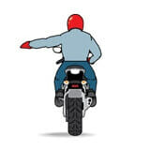

**Left turn**

For letting the group know you are turning left. The signal can be used to break from or to lead the group, depending on whether you are leading or following. Make the signal by extending your left arm straight out with your palm facing down.

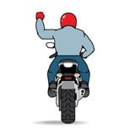

**Right turn**

Let the group know you are turning right. Use this signal to lead to break from the group, depending on your status (leading or following). Bend your elbow 90 degrees, then point your clenched fist at the sky to complete the signal.

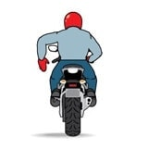

**Stop**

When the leader of the group makes the “stop” signal, it should cause a chain reaction going all the way back to the last rider in the group. Make the signal by bending your arm 90 degrees, keeping your palm open, and pointing your fingers down at the road.



**Speed up**

Inexperienced groups will benefit most from this signal. Experienced groups rely more on body language. Use it to tell the rest of the group to match your pace by increasing their speed. Extend your arm and swing your palm in an upward direction to give the signal.



**Slow Down**

This signal is useful because motorcycles generate intense engine-braking forces, which do not activate the rear-facing brake light. Extend your arm and swing your palm down toward the road to tell everyone in the group to slow down.

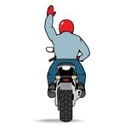

**Follow Me**

Used to announce a new, often self-appointed group leader. It is also used to segment a large group into smaller groups. Make the signal by extending your arm forward at the shoulder with your palm facing outward.



**You Lead/Come**

Also known as the “YOU! Follow me!” signal. It has 2 distinct parts. Start by pulling up alongside the rider you want to follow or lead. In one motion, point to their bike and then swing your arm forward. Repeat this motion until the other rider understands.

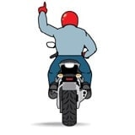

**Single File**

An easy gesture. Extend your left index finger and bend your arm up to the sky. In other words, pretend the riders behind you are asking “How many?” and then indicate the answer by gesturing with your *left pointer finger.*

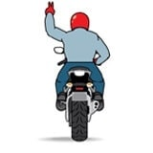

**Double File**

Bend your left arm at the elbow and point to the sky with your index and middle fingers. Do not forget to include your index finger.



**Comfort Stop**

Poke your arm out to the left and shake your fist using short, up-and-down movements – as though shaking a can of paint. Make this stop only when the road or shoulder is debris-free and there is ample room to pull over.

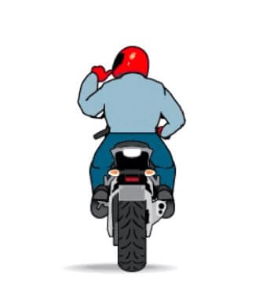

**Refreshment Stop**

Indicate your intention to stop at a gas station or restaurant. Make a “thumbs up” with your left hand and gesture toward your mouth (or the front of your helmet) as though your thumb is a straw poking up out of a glass of water.



**Turn on Signal**

To make a “blinking” gesture using your left hand, alternate between extending your fingers and making a fist. Use this signal to let another rider know he left his blinker on, allowing him to save face during the next comfort or refreshment stop.



**Pull off**

Indicate to the rest of the group to pull off the highway immediately or at the next exit. The pull off signal is given when the reason for the stop is something other than a comfort or refreshment stop.



**Police Ahead**

Let your fellow riders know about police activity up the road by patting the top of your helmet with your left palm. Keep our communities’ police officers and other first responders safe. Use caution and respect all laws when riding your motorcycle. Remember to follow best practices in the event that you do get pulled over while on your motorcycle.

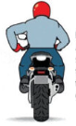

**Fuel Stop**

When riding with most groups, running out of gas will earn you a nickname you probably won’t like. Communicate your need to refuel by pointing to your fuel tank using your left index finger.

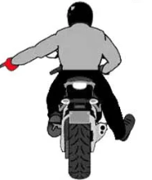

**Hazard in Road way**

Point at hazard with arm or leg.